## Database Programming with SQL

## 11-1 Ensuring Quality Query Results

1.Write the Query • Problem:

−Create a list of all tables whose first two characters in the name of the table is JO −The tables must be owned by the current Oracle User • Tables Used: −User_tables

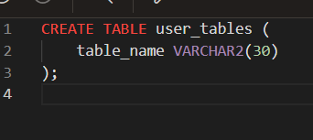

2. Creating employees table

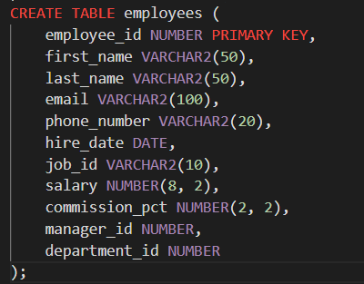

1. Creating jobs table

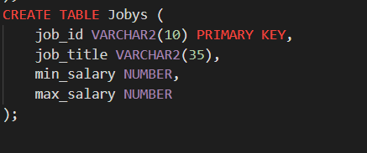

1. Creating departments table

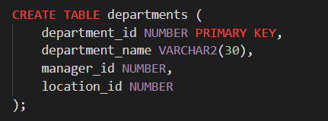

1. Creating locations table

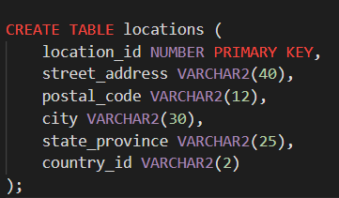

1. Creating job_grades table

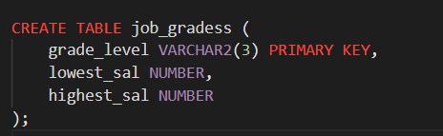

1. Inserting sample data into the tables

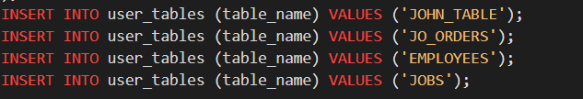





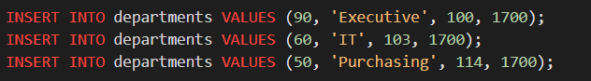

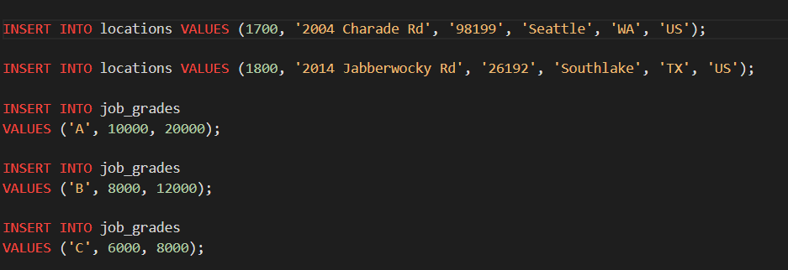

1. List of tables whose name starts with "JO"

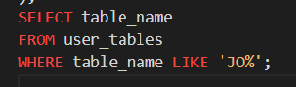

1. List with the first initial of every employee's first name and the last name



1. List of employees' full names and emails containing 'IN'

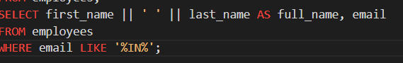

1. Smallest and highest last names



1. List of weekly salaries between $700 and $3000

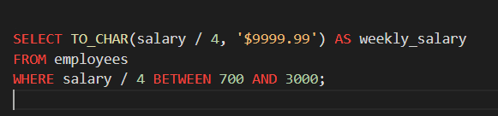

1. List of employees and their job titles sorted by job title

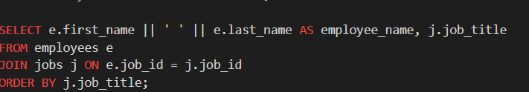

1. List of employees' jobs, salary ranges within jobs, and the employee's salary

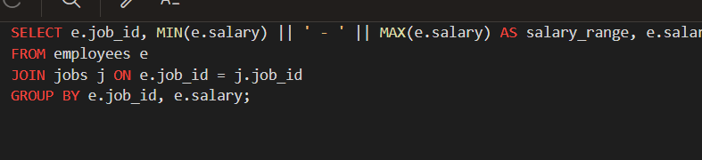

1. List of employees' first initial, last name, and department name using ANSI join

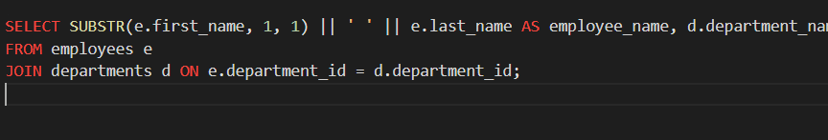

1. List of employees' first initial, last name, and department name joined only on department_id

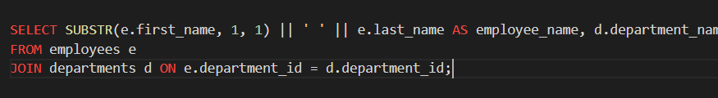

1. List of employees' last names and whether they have a manager using DECODE

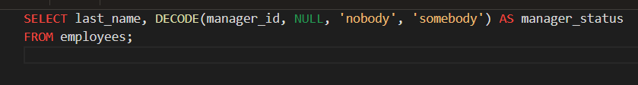

1. List of employees' first initial, last name, salary, and if they make commission (fixed query)

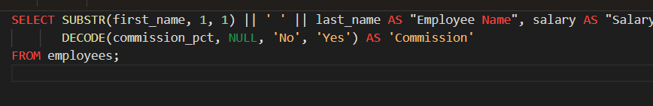

1. List of employees' last name, department name, city, and state_province including departments without employees

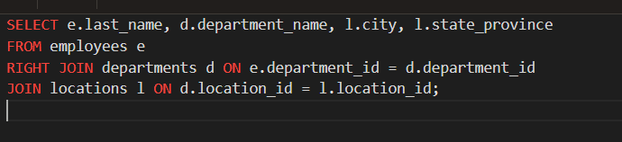

1. List of employees' first and last names, first occurrence of commission_pct, manager_id, or -1

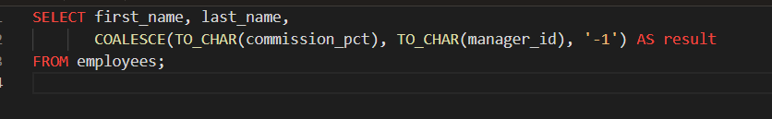

1. List of employees' last name, salary, and job_grade for departments with department_id > 50

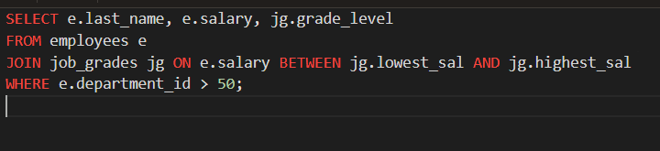

1. List of employees' last name and department name including both employees without departments and departments without employees

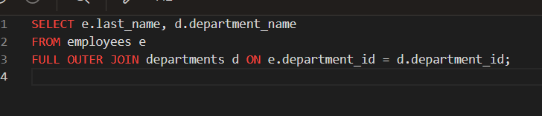

1. Treewalking list of employees' last name, their manager's last name, and their position

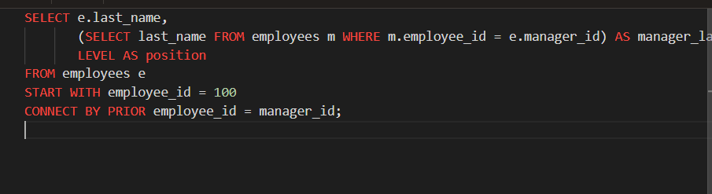

1. Earliest hire date, latest hire date, and number of employees

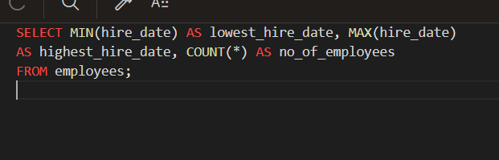

1. List of department names and departmental costs between $15000 and $31000, sorted by cost

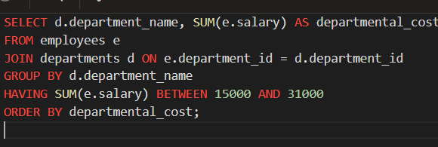

1. List of department names, manager id, manager name, and average salary

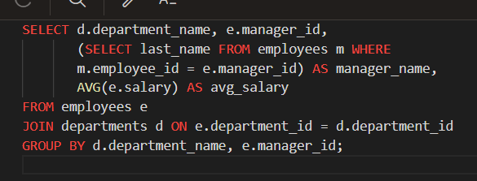

1. Highest average salary for departments rounded to the nearest whole number

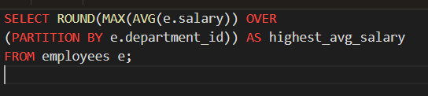

1. List of department names and their monthly costs

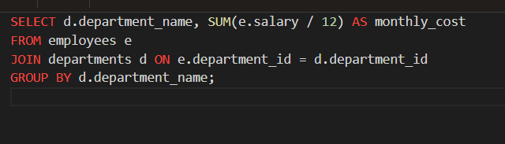

1. List of department names, job_ids, and monthly salary cost for each job_id within a department, and for all departments

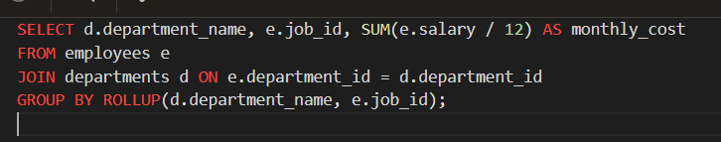

1. Expanded list with CUBE and GROUPING

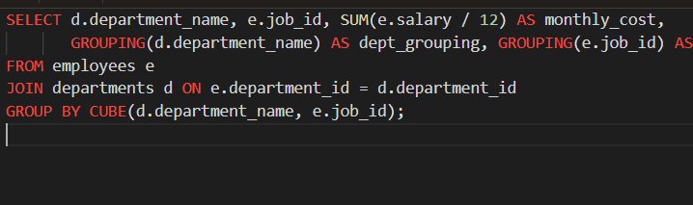

1. Monthly salary costs for each job title within a department and per city

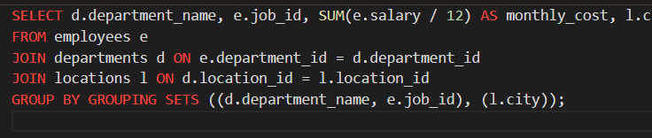

1. Employee names and department ids, department ids and department names, and cities using UNION

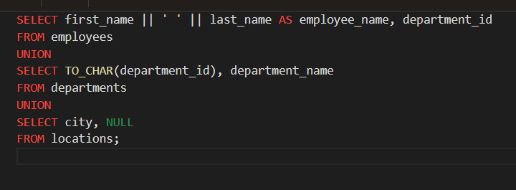

1. List of employees' first initial, last name, salary, and department name for those earning more than the department average

